Beginner Violin Class
Susquehanna University Prep Program
Pre-Twinkle Songs Compiled by Jennifer Sacher Wiley
(attributed to pedagogues Mimi Zweig and Bonnie Greene)

Up Like a Rocket

“Up Like a Rocket
Down Like the Rain
Back & Forth like a Choo Choo Train
Round & Round like a Great Big Sun
Land on your Head
Curve your Pinky and your Thumb”

AEA/GDG

A E A (rest/stomp)
A E A (rest/stomp)
A A E E
A E A (rest/stomp)

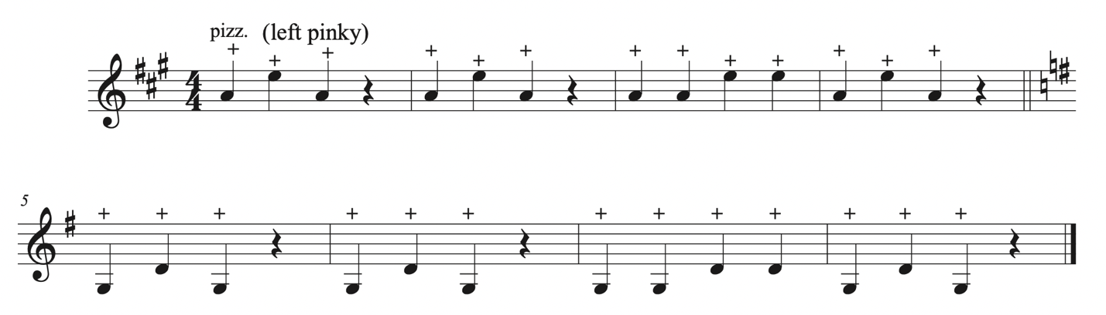

Around the World
(bow circles)

G, D, G, D
A, E, A, E
A, D, G
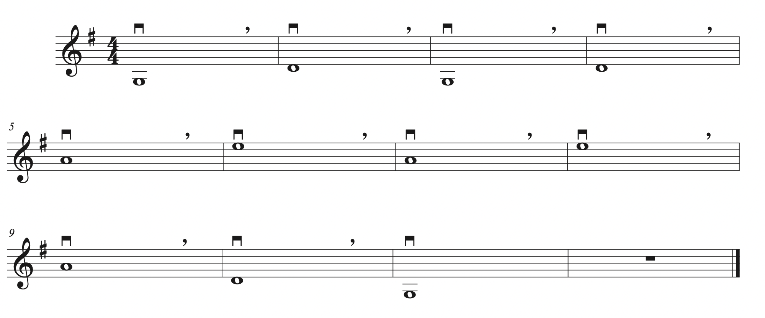

Bow Wanderings

E 13 strokes (wander from frog to tip, Rock to A)
A 13 strokes, (wander from tip to frog, Rock to D)
D 13 strokes, (wander from frog to tip, Rock to G)
G 13 strokes (wander from tip to frog)
Listen for piano and answer “Frog, tip!”
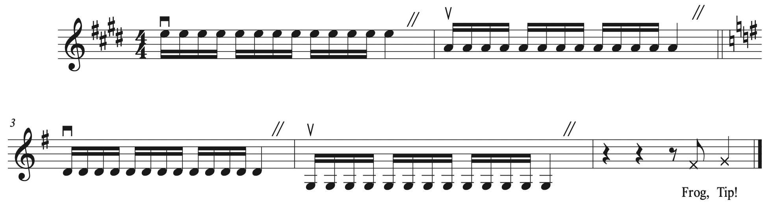

See Saw

“See Saw See Saw I like to play on my See Saw”
EAEA 111111 AA
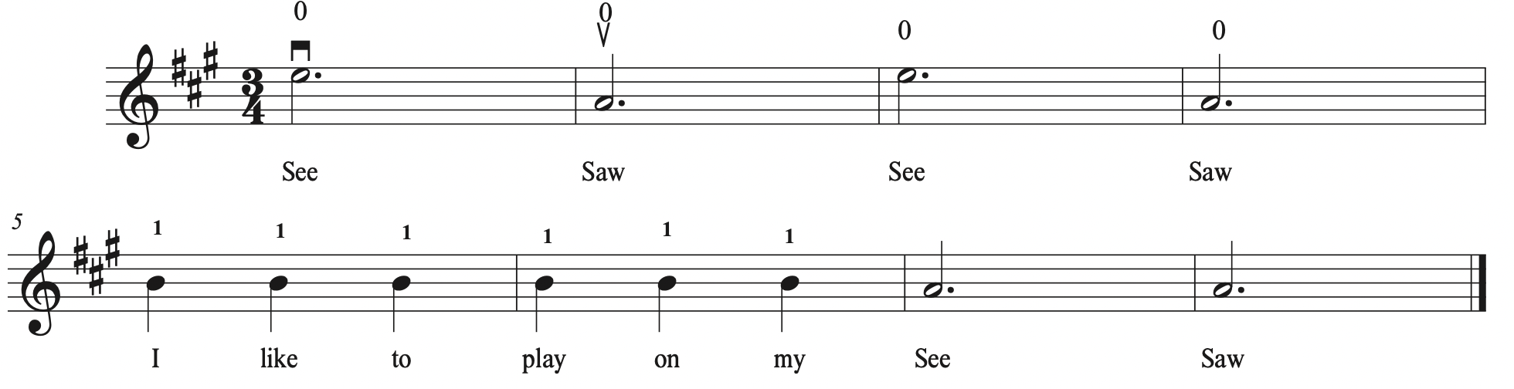

See a Little Monkey
(all on A string, call & response)

“See a Little Monkey” AAAAAA
“Climbing up a Palm Tree” 111111
“Climbing way up high to” 222222
“Pick a pink banana” 333333
See a Little Monkey” 333333
“Climbing down a palm tree” 222222
“Climbing way down low to” 111111
“Eat the pink banana” AAAAAA
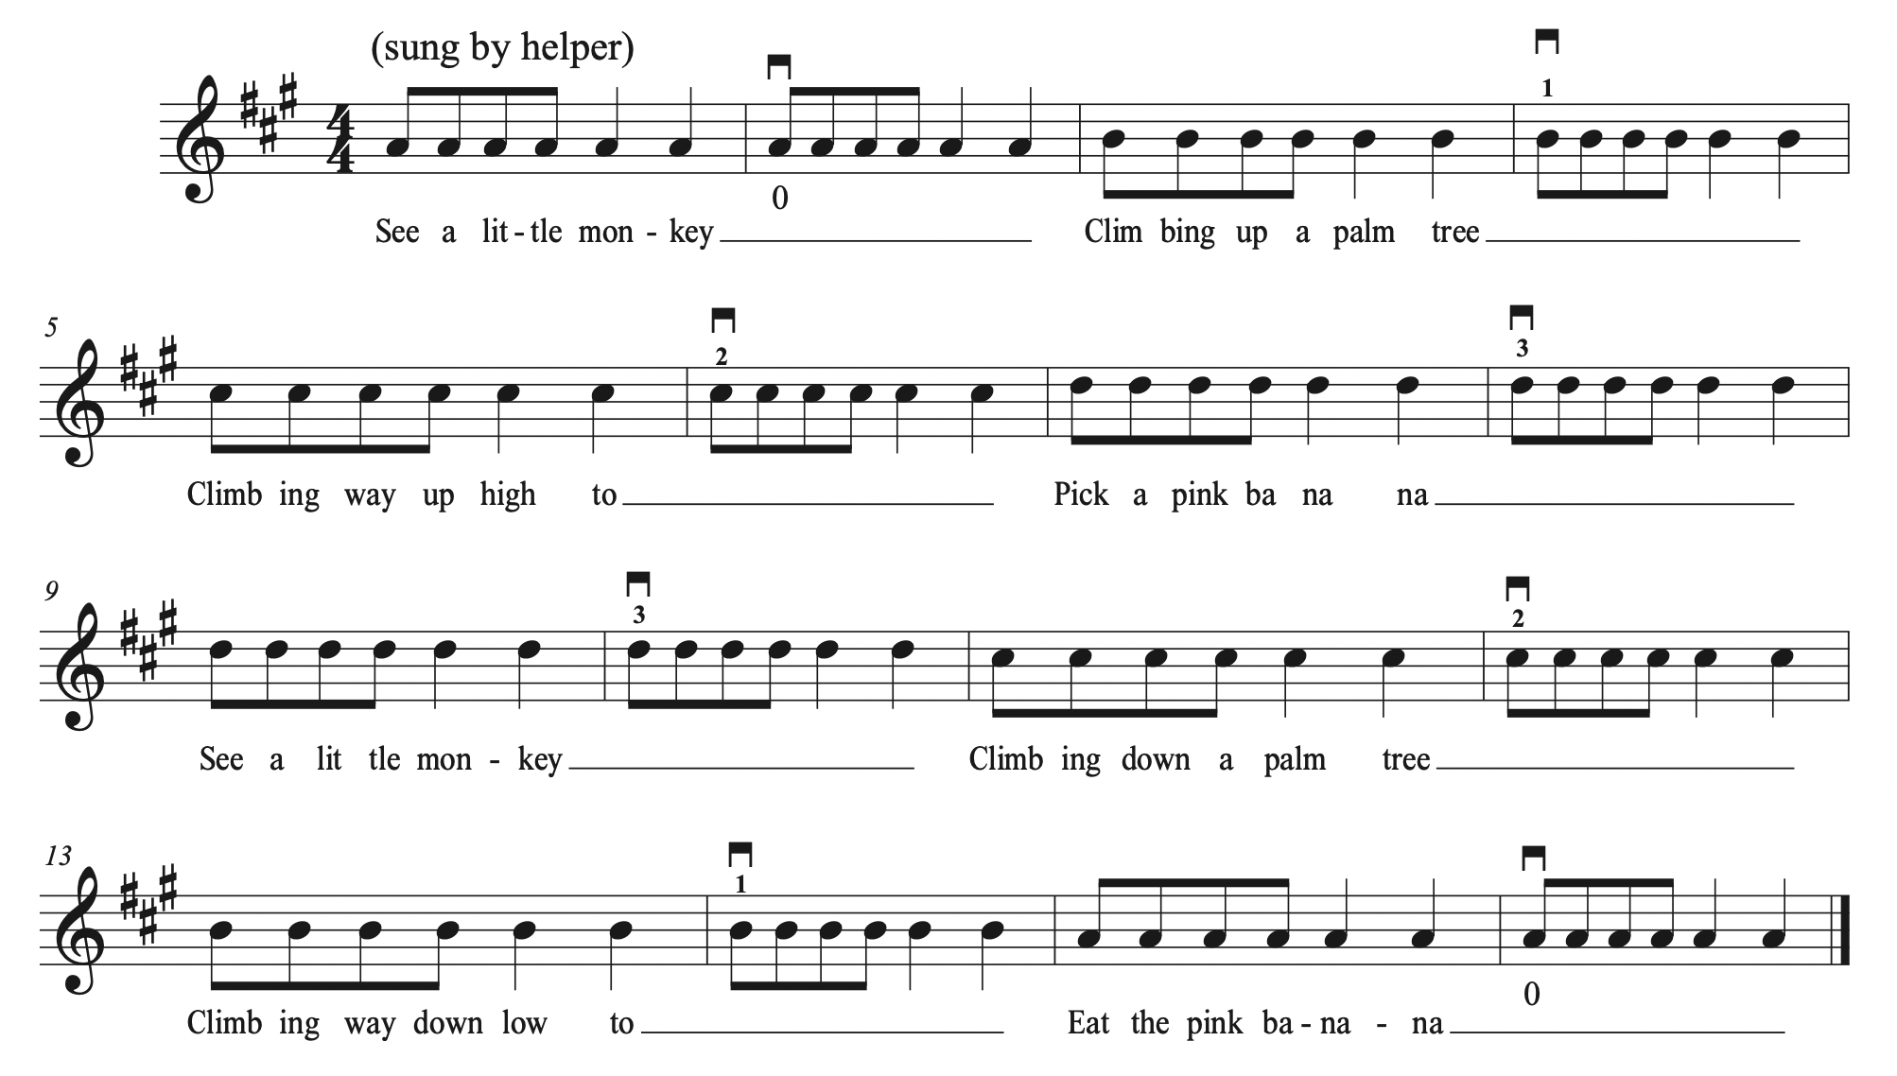

Mississippi Hot Dog Twinkle

Bread: AAAAAA EEEEEE 111111 EEEEEE (stop, rock to A string, place 3 fingers)
333333 222222 111111 AAAAAA
Peanut butter: EEEEEE (stop, rock to A, place 3 fingers) 333333 222222 111111
Jelly: EEEEEE (stop, rock to A, place 3 fingers) 333333 222222 111111
Bread: AAAAAA EEEEEE 111111 EEEEEE (stop, rock to A string, place 3 fingers)
333333 222222 111111 AAAAAA
