Shifting the System

An Early Intermediate Violin Shifting Book featuring works by Women, Black & Indigenous People of Color, and Global Folk Music

By Jennifer Sacher Wiley

Group 3 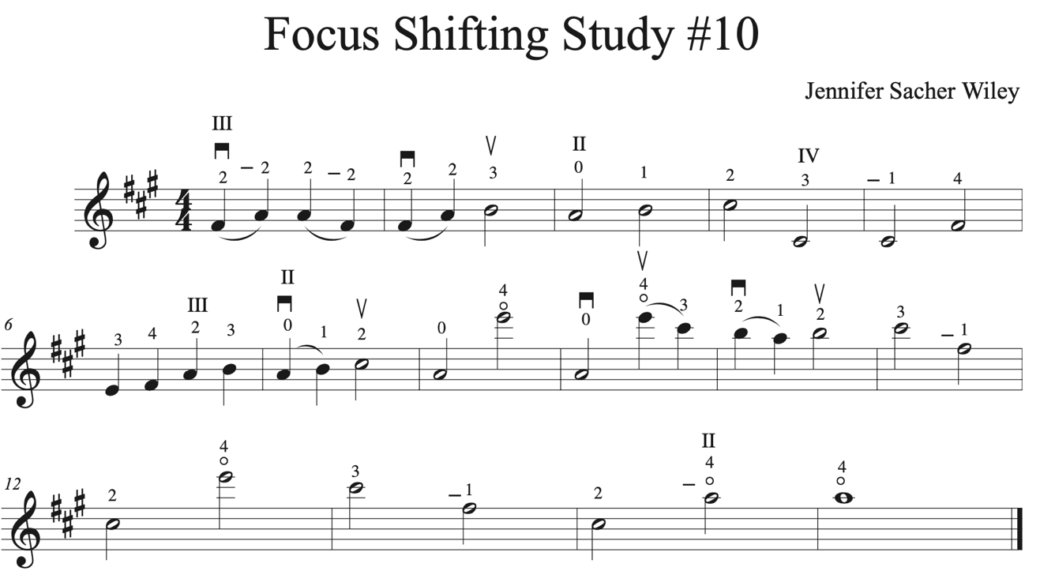

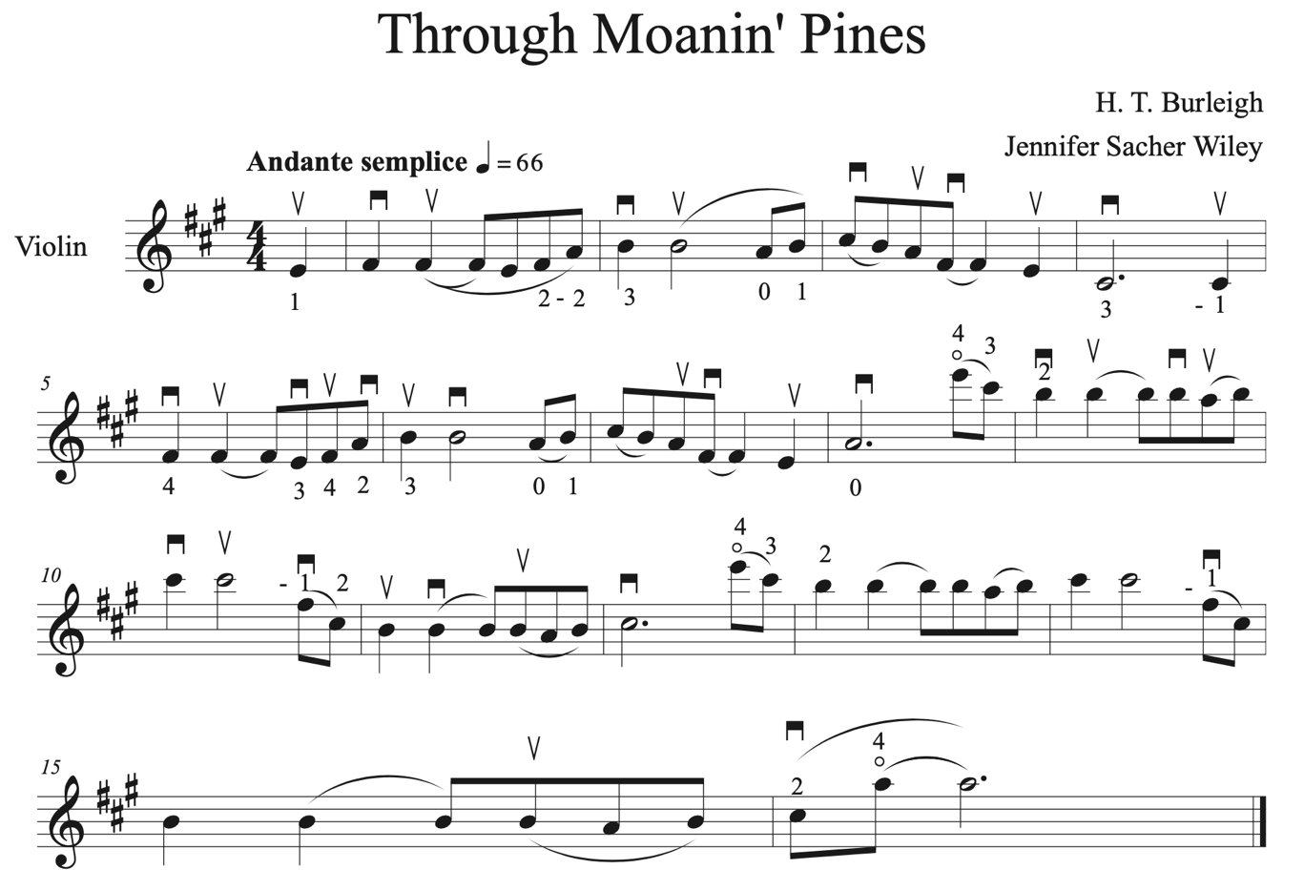

Focus Shifting Study #11

Focus Shifting Study #12



Caritas abundant

Hildegard von Bingen

