Shifting Journeys
Piano accompaniments by Jennifer Sacher Wiley

“Lady Meng Jiang”, a Chinese Folk Song

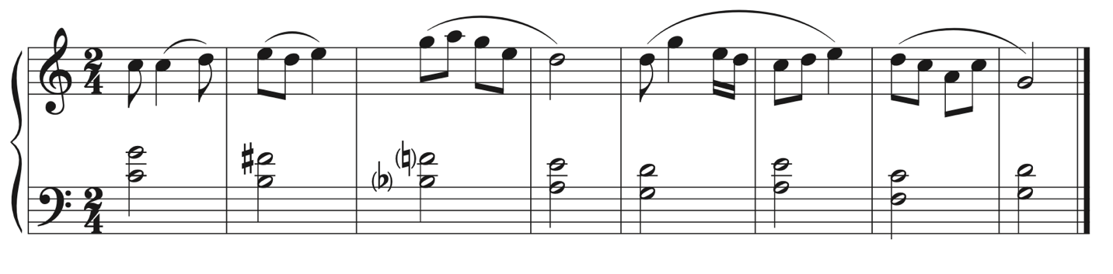

Pueblo Flute Song

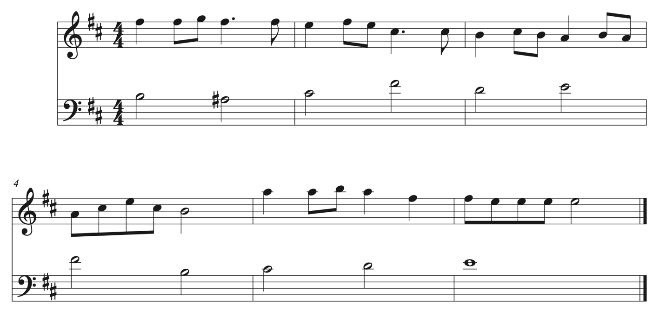

“Rahelica baila”, Sephardic folk song

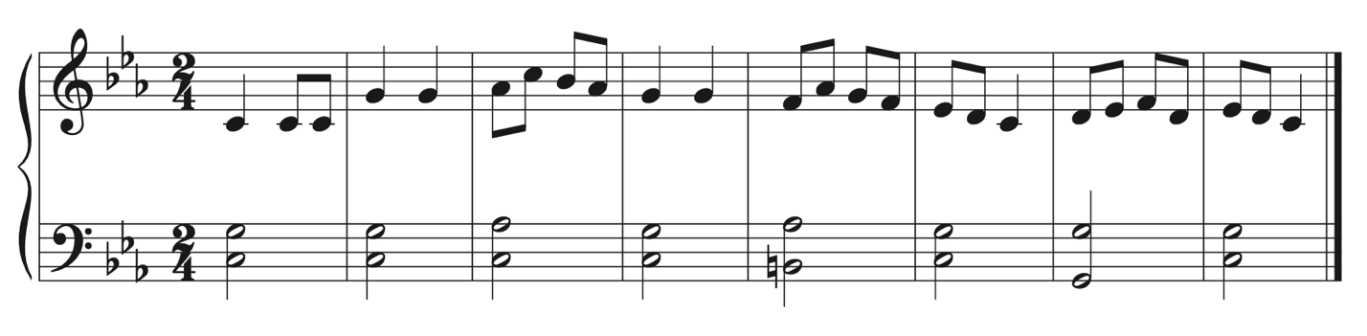
Cabin Song, by Clarence Cameron White

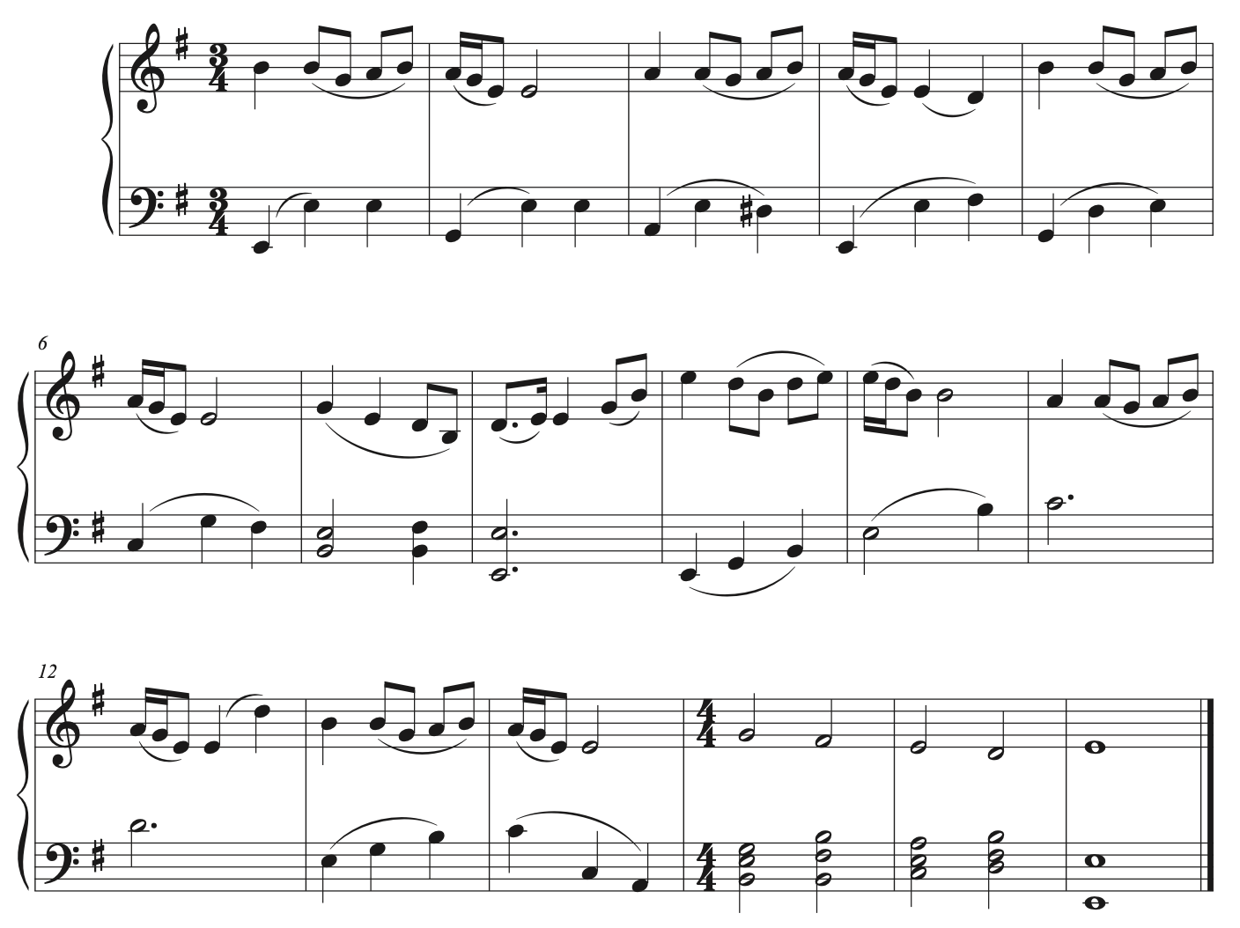

“Fogo, Foguinho” by Francisca Gonzaga

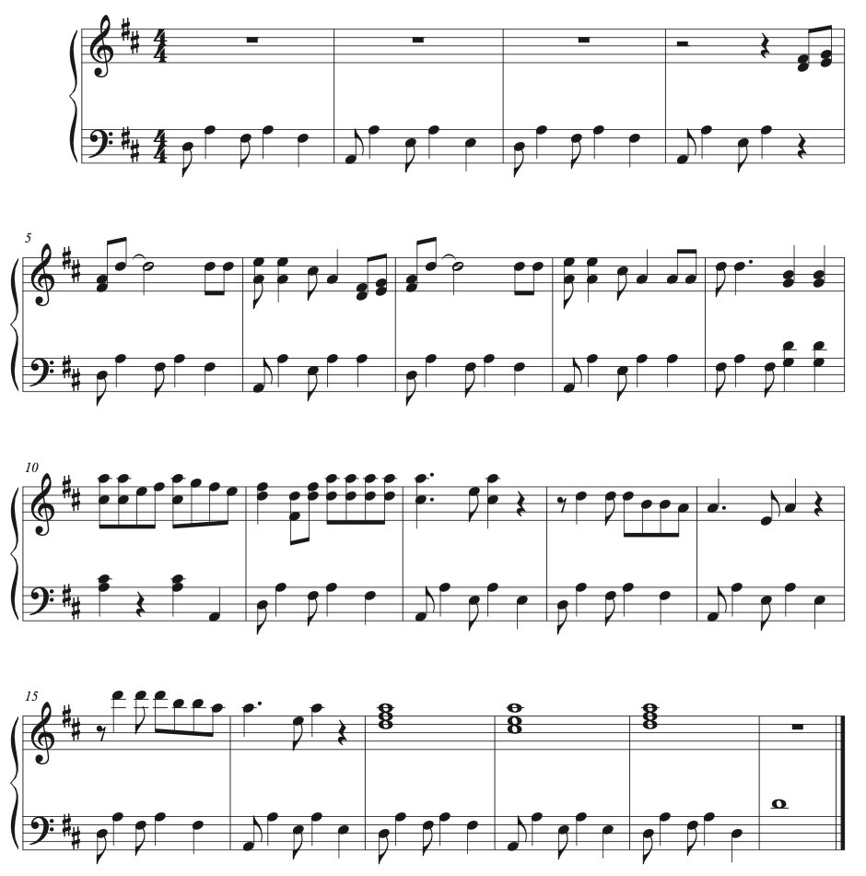

“O Virga ac diadema”, by Hildegard von Bingen

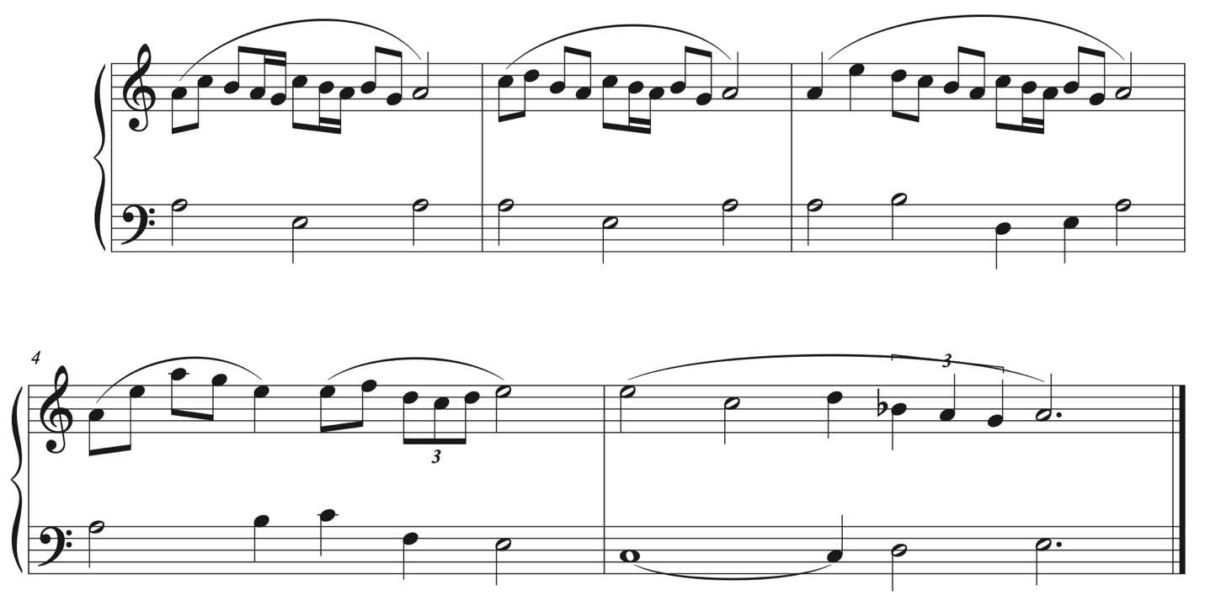

Drake’s Drum, by Samuel Coleridge-Taylor

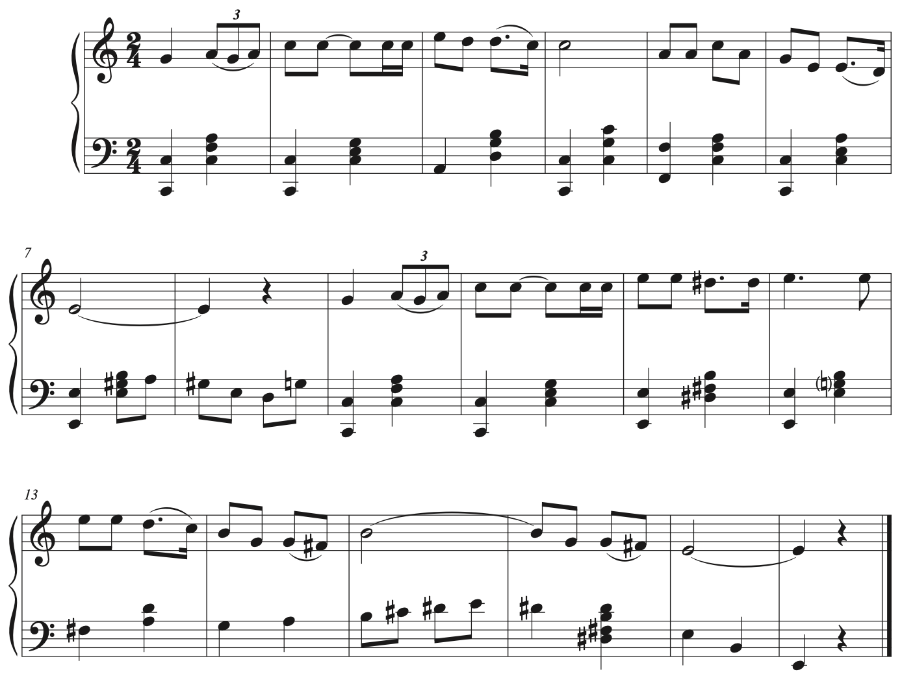

Spiritual, by Clarence Cameron White

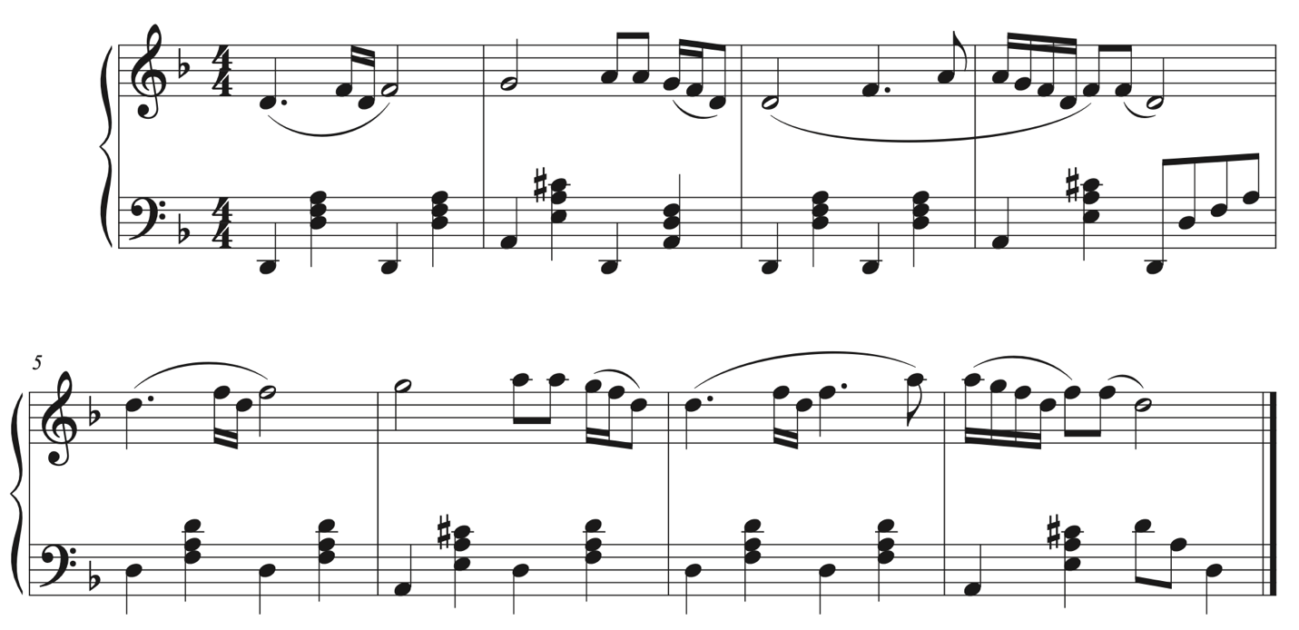

“Ch’amor” by Francesca Caccini

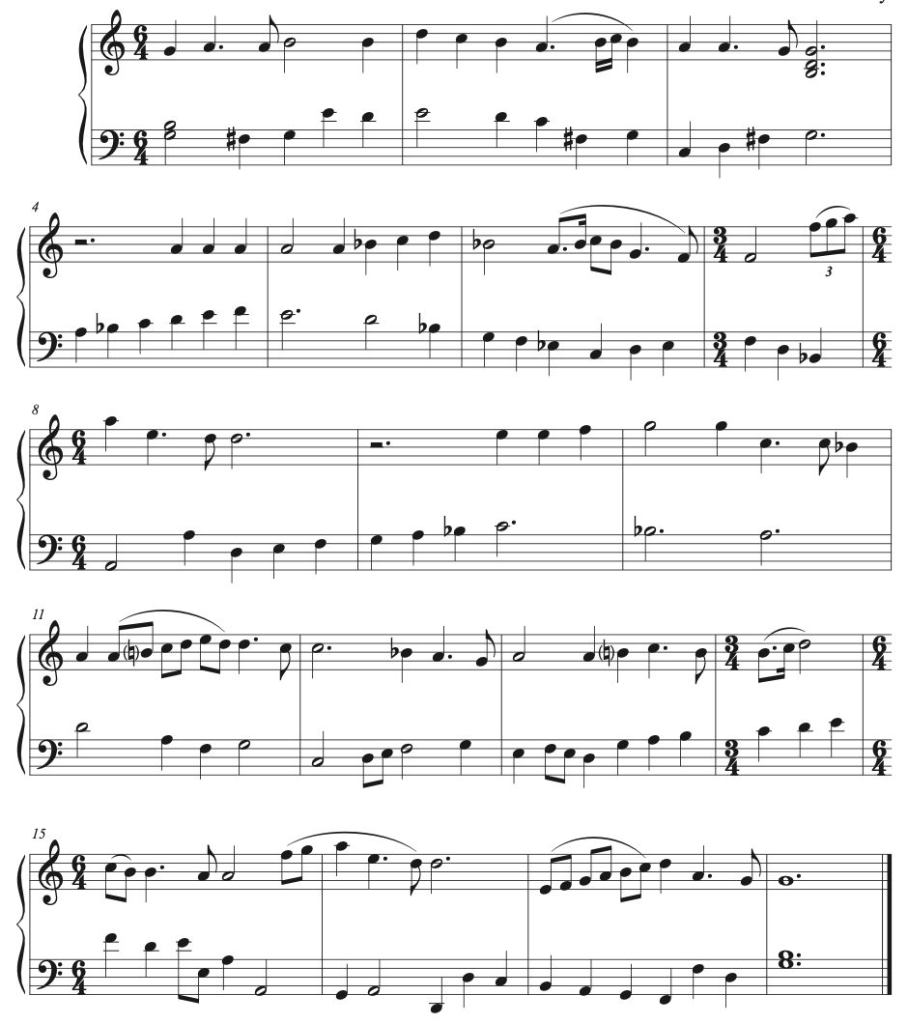

“Through Moanin’ Pines” by Harry T. Burleigh

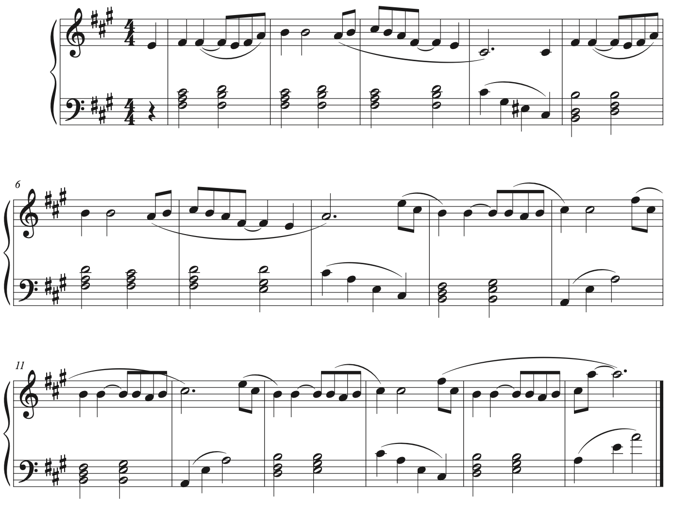

“Aire de mujer”, Sephardic song

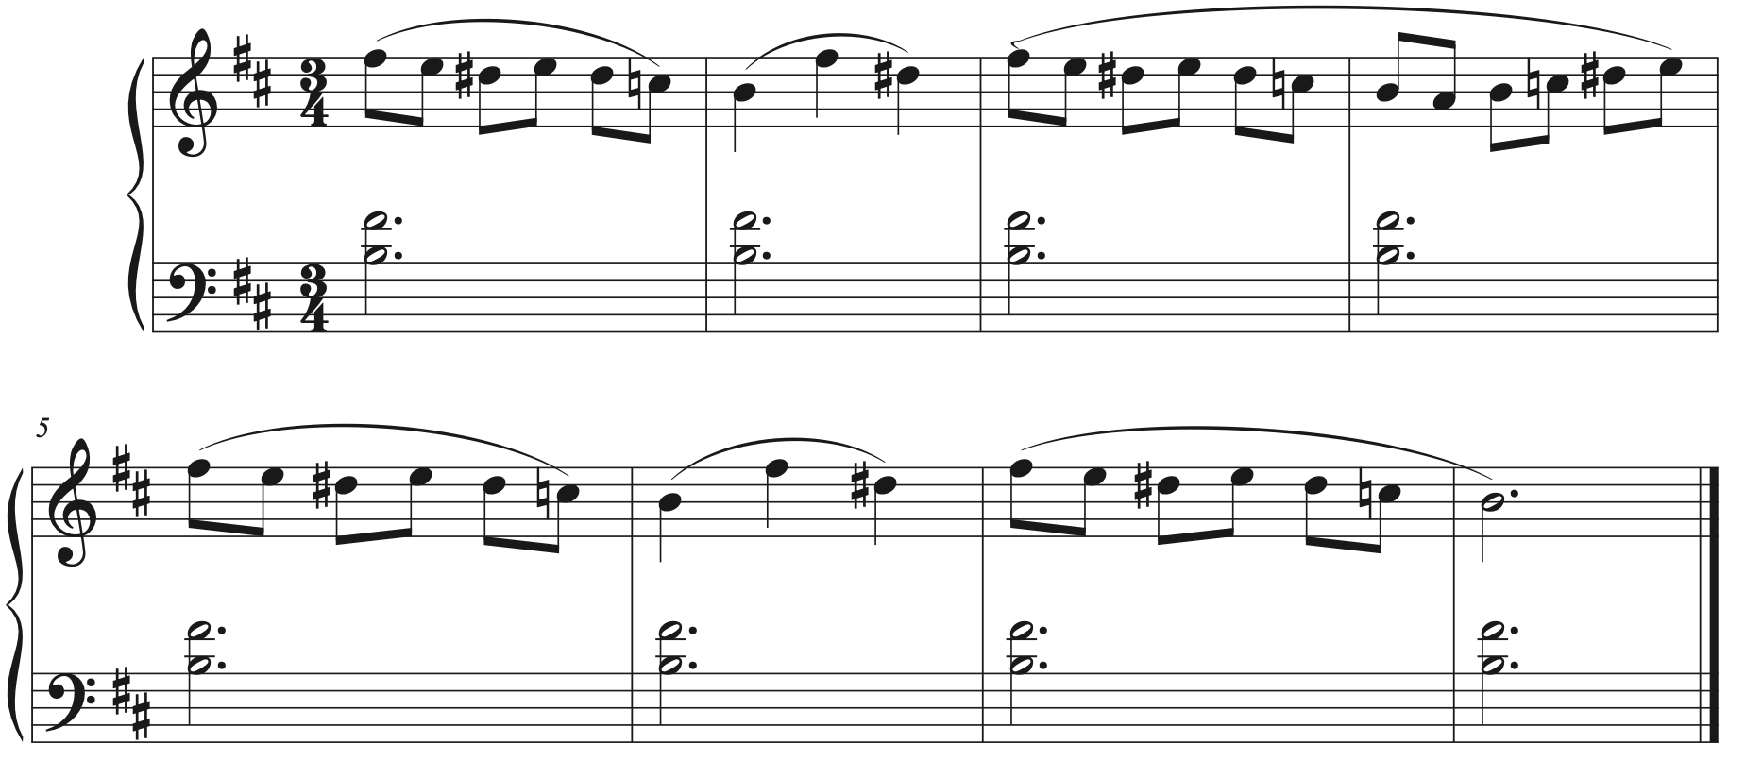
“Caritas abundant” by Hildegard von Bingen

