Shifting the System

An Early Intermediate Violin Shifting Book featuring works by Women, Black & Indigenous People of Color, and Global Folk Music

By Jennifer Sacher Wiley

Group 2

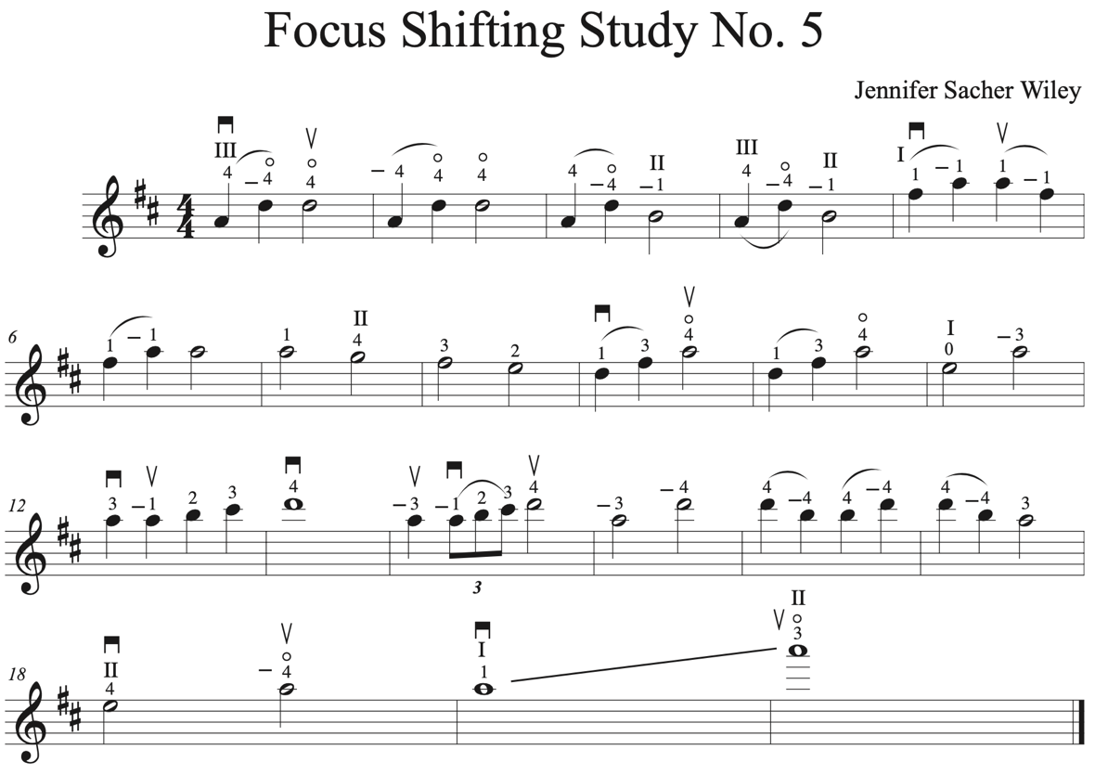

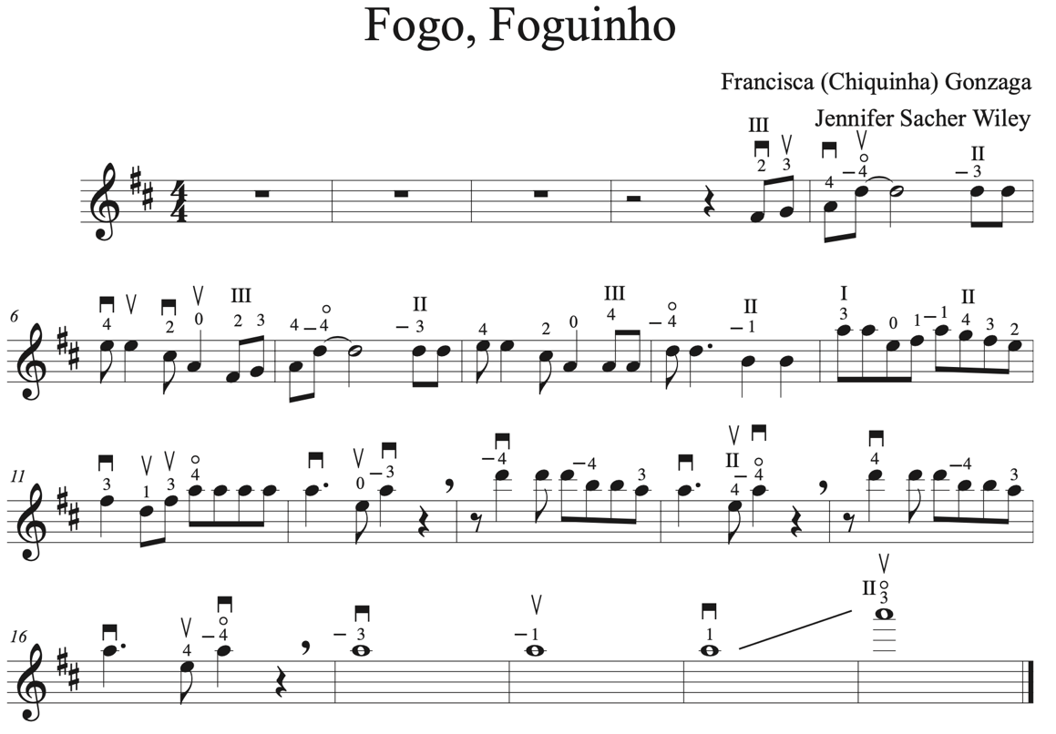

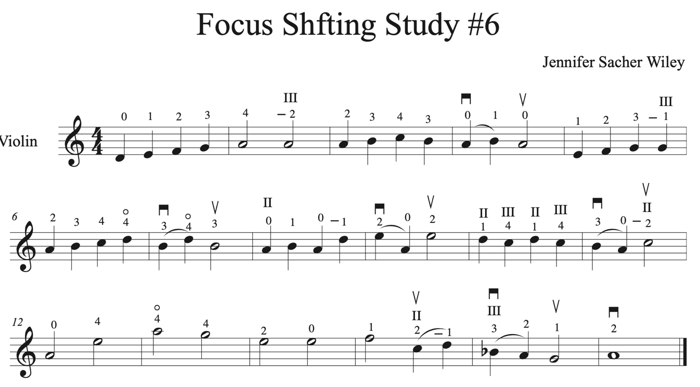

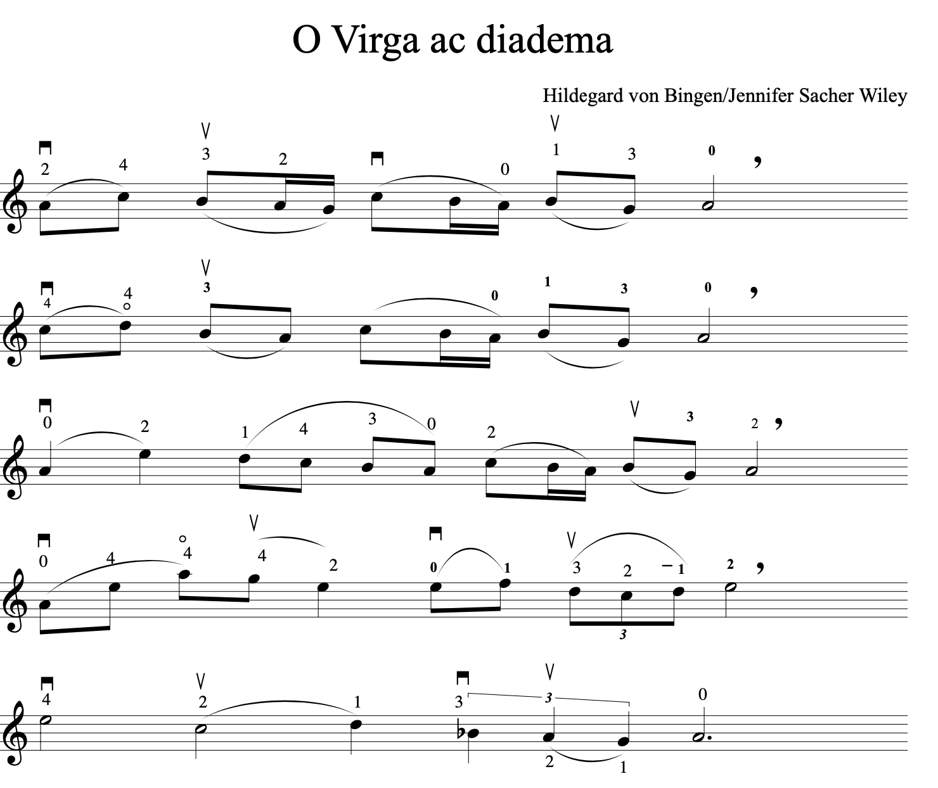

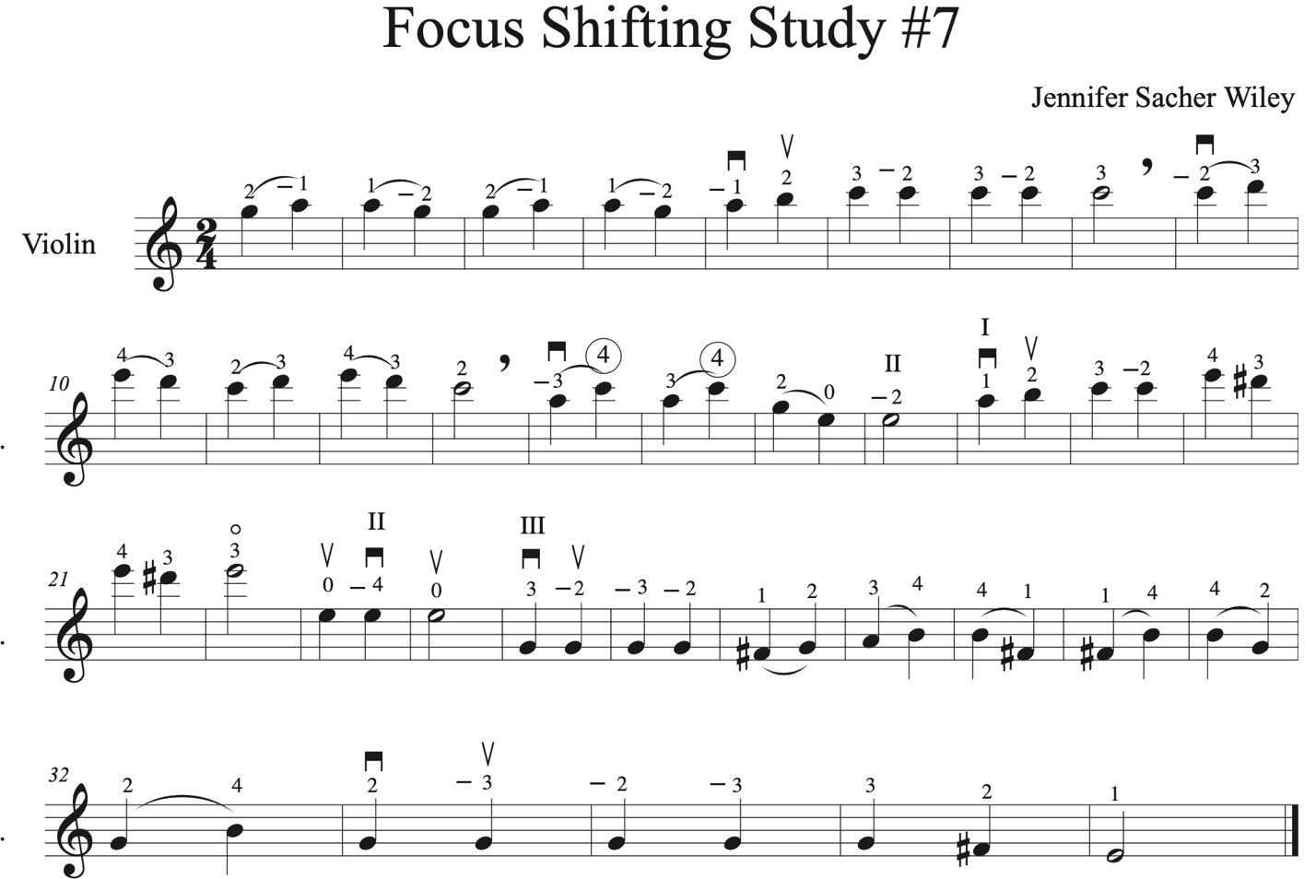

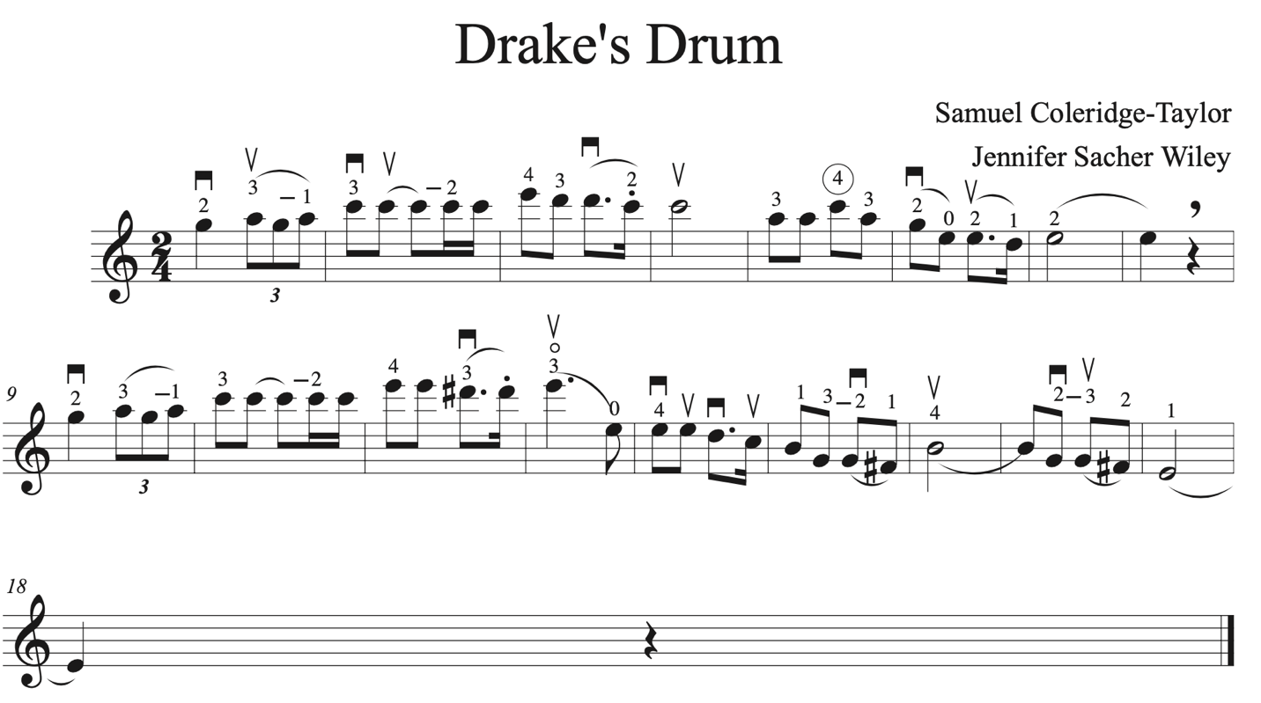

Focus Shifting Study #8

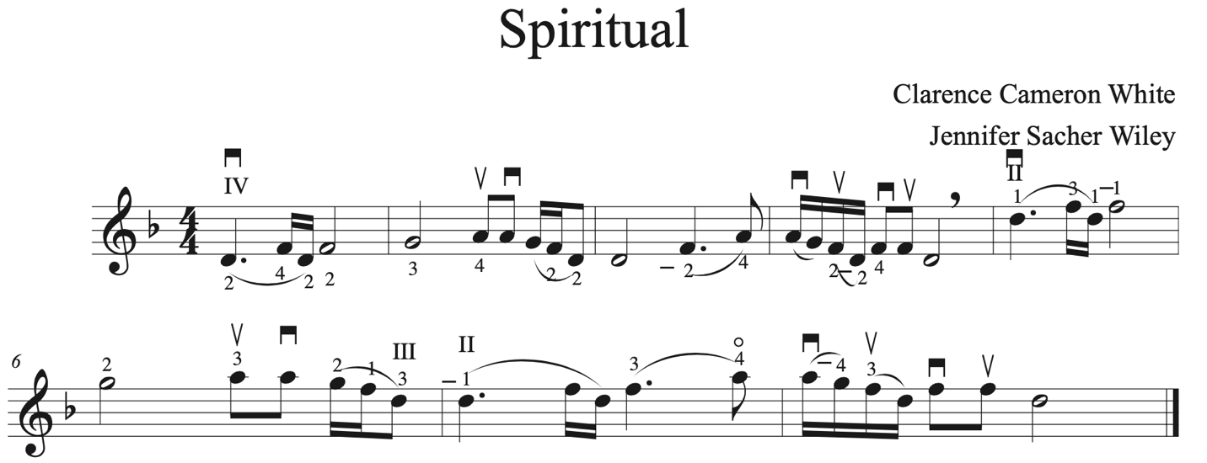

Focus Shifting Study #9

